CLASS 4 SUMMER TERM OVERVIEW – WHAT A WONDERFUL WORLD
MATHS: please refer to separate overview for lessons to be set this term.
ENGLISH: please refer to weekly lesson overviews – our focus is going to be on writing shorter pieces of work and really thinking about the quality of our ideas and how we need to think carefully about choice of language to engage the reader. Please don’t forget about using SPELLING FRAME!
READING:
I am going to be reading a very recently published first novel by the author L.D Lapinski, titled ‘The Strangeworld’s Travel Agency.’ I came across this novel quite by chance and the blurb caught my attention. I’ve now finished it and am looking forward to sharing it with the children at school. I have uploaded the text for chapters 1-10 so far so that the children can also read it themselves. I am intending on reading 1-2 chapters per day and would like ideally to do this on Zoom rather than upload me reading these. Until I start back with year 6 on Monday, I’m not quite sure about timings of breaks, etc. so I’ll need a couple of days to get back into the swing of things I think. I’d like to start zoom sessions from Wednesday. They won’t be too long – it’ll basically be me reading the book. However, it would be nice to see lots of faces as I’m sure that they’ll enjoy it. My ID and password remains the same, but I will send a separate parent mail with these details as a reminder.
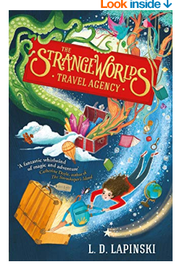 | 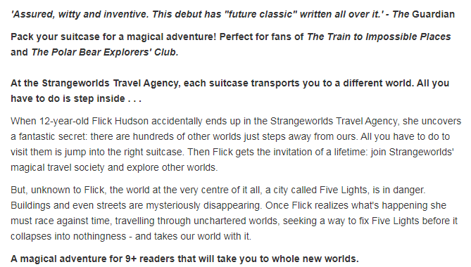

TOPIC:
This term we are going to have a completely different topic focus: What A Wonderful World. I would like the children to be geographers this term, to use google maps, look at images and to watch suitable video clips in order to broaden their knowledge of our world.
This publication below may be of interest for those of you who subscribe to Amazon Prime – it is free at the moment, although I have no idea how long this will be the case!
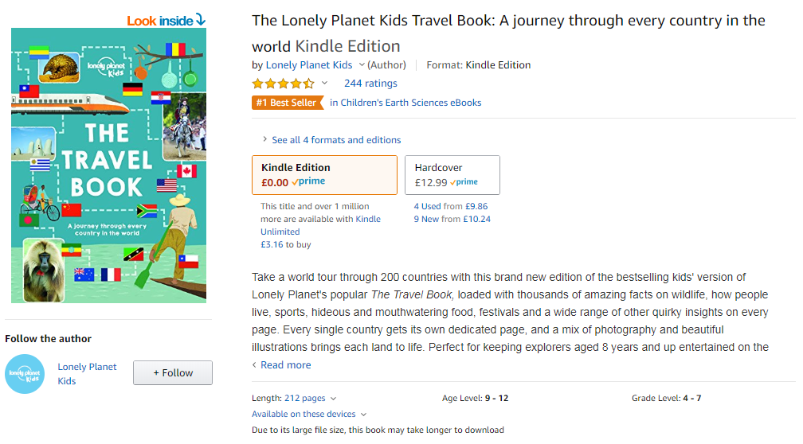
This term, I won’t be indicating when the children should attempt different tasks or in what order. I would like the children to see how well they can manage their time with this. I have uploaded some different activity booklets that they can choose tasks from which most interest them.
In addition to the booklets I have uploaded, I would like the children to have a go at researching two different countries in different continents in order to compare and contrast them. I would like them to choose for themselves how to present their findings (powerpoint, video recording themselves being ‘roving travel reporters’, publisher, etc.) Please look at the compare and contrast fact file planning sheet (which follows later on in this document) for suggested content to research.

Related web links
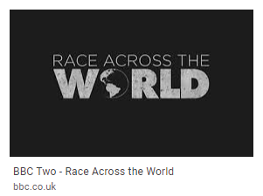You may already be familiar with this series (we absolutely loved both series!) and this may be of interest to the children given our topic theme. Of course it is up to you as parents to decide on if you feel it is suitable for your child to watch. All episodes are available on iPlayer for the next few months.
https://www.bbcearth.com/earthkids/
https://www.natgeokids.com/uk/category/discover/geography/
https://www.bbc.co.uk/bitesize/articles/zk3nscw
https://www.bbc.co.uk/bitesize/subjects/zbkw2hv

