YEAR 6 Week 1 (w/b 20th April 2020)
Hello everybody! I hope that you are all keeping well and that you have been able to enjoy the lovely weather over the Easter break.
In this pack, there are a variety of lesson plans and ideas for you and your child to do at home. Daily maths and English has been set; the English work will build up to an extended final piece of work.
Daily timetables have also been included to help with your planning but please do continue to decide on a structure that suits your family routine.
Here follows some important information that I will only include on this week’s planning!
MATHS
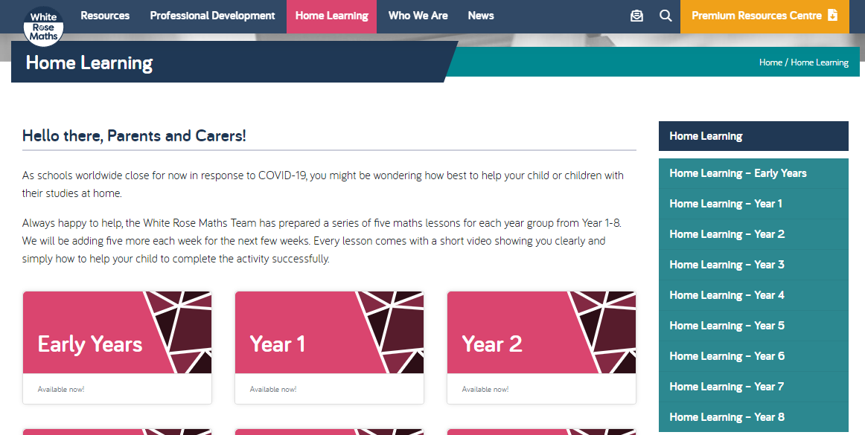Our MAIN daily maths activities continue to be found on the White Rose Maths website under the Home Learning section (week 1 lessons 1-5 were given to your children in the white envelopes on our last day in school, to be completed by the Easter holiday). Each day there is a short video clip to watch prior to doing the worksheet. It is not necessary to print out the worksheets unless you really wish to do so. Children are very used to seeing these style worksheets and are in a good routine with the format of these; the activities get trickier on the second page. I would not expect everybody to be able to do the last question. Answers are provided for each lesson. Please do look at these with your child. If your child is struggling with a question, encourage them to persevere and, if appropriate, let them have a look at the answer and see if they can then work backwards to see what they need to do to reach the answer. This is often an effective strategy we use in class on occasions. However, there will be some questions on each worksheet that some children will simply find that bit more challenging without the support and modelling that they benefit from in class. All I ask is that they simply try their best. It is not a failure to not be able to do every single question. I strongly suggest that the children pause at appropriate moments in the video clips to think about what has been explained and to do workings out as the presenter demonstrates question types. I also strongly urge the children not to skip the video clip so to avoid misconceptions and making careless mistakes.
Each day, there will also be a problem solving powerpoint slide available and an investigation task once per week for those children that may want to do some extra maths. The most important thing for me is that the children work through the White Rose lessons and try their best with these.
I would be most grateful if you could keep a note of which lessons your child finds particularly challenging and let me know about this via email. It might be that I am able to send you a suitable alternative task to be attempted at home, or it may be that I can reassure you that I will make this a priority to re-visit in class when we come back to school. Likewise, if you would simply like to let me know that all is going well, I will be very happy to hear from you.

ENGLISH
If we had been in school, we would have been studying ‘Goodnight Mr Tom’ for the duration of this term. However, given the circumstances, I have decided to go with an alternative text to get us going (still based on WWII) called ‘Friend or Foe’ by Michael Morpurgo. This is quite a bit shorter but every bit as relevant to our topic. This does not need to be purchased. The following link will be important (BBC radio abridged version) and I will copy extracts where needed for reading / grammar activities. Our written work will be linked to the text and clearly tie in also with our topic, ‘A Child’s War’.
https://www.bbc.co.uk/teach/school-radio/english-ks2-friend-or-foe-michael-morpurgo-index/znb78xs
Or, you can simply google Friend or Foe BBC schools radio.
Spellings are still accessible on Spelling Frame. I have released these all in one go with a deadline of July rather than release week by week. Please do encourage your child to do with on a weekly basis – they can choose the order in which to do them!
I would love to see how the children are getting on with their written work. If you can email me documents (if they have typed up their work) or photos of the work produced on paper, I would really appreciate that. Additionally, if you would like to send in any short video clips of your child reading aloud (they often can’t wait to read aloud in school) then please do so. Anything you would like to share, I’ll be happy to receive!
Daily timetable: Monday
Early morning task | Some suggestions for you to choose from:  Reading, spellings, Timetables Rockstars, Study Ladder, Joe Wicks P.E.
1 hour | English: Introduction to children’s World War II fiction.  Powerpoint – match the blurbs to the titles  A shorter activity today as more written work later on in the week.
30 minutes | Break
1 hour | Maths: White Rose Maths (home learning) https://whiterosemaths.com/homelearning/  Year 6: Week 2 lesson 1 – calculating scale factors  Problem solving day 1
1 hour | Lunch
1 hour | History – When did WW2 start and why? Make some notes and keep them somewhere safe for the time being.  Remember to look at age-appropriate websites (include KS2, primary, for children, etc.)  Who declared war? When? Why? Who was the enemy? What had they done / not done? What was the immediate concern for the British Government?
Rest of afternoon | Fresh air, Outdoor learning or Art or PE (see ideas sheets)
Evening | Reading for pleasure – to an adult/older sibling.

Daily timetable: Tuesday
9.15 – 9.45 | Morning activity: Reading, spellings, Rockstars Timetables (or you might want to do your Joe Wicks/other PE activity
9.45 – 10.30 | English:  Tuesday’s Powerpoint (main focus on comprehension)  Chapter 1 of Friend or Foe (PDF file of chapter is on BCS website)  Also listen to (episode 1) on https://www.bbc.co.uk/teach/school-radio/english-ks2-friend-or-foe-michael-morpurgo-index/znb78xs  There will be some minor differences between the written text and the audio as the audio is an abridged version. However, it is still useful to listen to while reading along.
10.30 – 10.50 | Break
10.50 – 11.50am | Maths  Year 6: Week 2 lesson 2 – ratio and proportion problems  Problem Solving Day 2
11.50 – 12.50pm | Lunch
1pm – 2pm | Over the course of the next 3 days, find out as much as you can about Operation Pied Piper. Put your findings in a powerpoint presentation or publisher or maybe record yourself giving a report about it.  What was it? When did it happen? Why was it important? Who was affected by it? How long did it last for?
2pm onwards | Fresh air, Outdoor learning or Art or PE (see ideas sheets)
Evening | Reading – to an adult/older sibling, discuss the text and make a prediction….who is your favourite character?

Daily timetable: Wednesday
9.15 – 9.45 | Morning activity: Reading, spellings, Rockstars Timetables (or you might want to do your Joe Wicks/other PE activity
1 hour | English:  Wednesday’s PowerPoint (start of written focus – re-writing part of chapter 1 from the perspective of Mother)
10.30 – 10.50 | Break
10.50 – 11.50am | Maths  Year 6: Week 2 lesson 3– measure with a protractor  If you have a protractor at home, then all questions can be attempted. If not, please do not go and buy one! We will go over this at school. Most questions can still be attempted with the following exceptions:  Q1c, you can estimate but won’t be able to check yourself with a protractor to see how close you were.  Q3 g and h can be done but the other parts can’t be done without a protractor.  Problem Solving day 3
11.50 – 12.50pm | Lunch
1pm – 2pm | As with Tuesday
2pm onwards | Fresh air, Outdoor or Art or PE (see ideas sheets)
Evening | Reading – to an adult/older sibling, discuss the text and make a prediction….who is your favourite character?

Daily timetable: Thursday
9.15 – 9.45 | Morning activity: Reading, spellings, Rockstars Timetables (or you might want to do your Joe Wicks/other PE activity
9.45 – 10.30 | English:  Thursday’s PowerPoint (re-writing part of chapter 1 from the perspective of Mother – lesson 2)
10.30 – 10.50 | Break
10.50 – 11.50am | Maths  Year 6: Week 2 lesson 4 – introduce angles (no protractor needed at all today)  Problem Solving day 4
11.50 – 12.50pm | Lunch
1pm – 2pm | As with Tuesday
2pm onwards | Fresh air, Outdoor learning or Art or PE (see ideas sheets)
Evening | Reading – to an adult/older sibling, discuss the text and make a prediction….who is your favourite character?

Daily timetable: Friday
9.15 – 9.45 | Morning activity: Reading, spellings, Rockstars Timetables (or you might want to do your Joe Wicks/other PE activity
9.45 – 10.30 | English:  Friday’s PowerPoint – Proof reading, editing and write up (or type) in neat of written task
10.30 – 10.50 | Break
10.50 – 11.50am | Maths  Year 6: Week 2 lesson 5 – calculate angles. All questions can and should be done without a protractor apart from Q1, so this one can be left out unless you have a protractor of course. This is because this step is getting the children to focus on using the angle facts that they have learned.  Problem Solving day 5  Mixed turbo table (don’t forget to time yourself!):  Numbers going across the bottom of the grid: 5,8,12,7,3,10,4,  Numbers going up the side of the grid: 7,3,8,11,4,6,2,10,1,9,12,5
11.50 – 12.50pm | Lunch
1pm onwards | Fresh air, Outdoor learning or Art or PE (see ideas sheets)
Evening | Reading – to an adult/older sibling, discuss the text and make a prediction….who is your favourite character?

