YEAR 6 Week 1 (w/b 11th May 2020)
Happy NON SATS week everybody! How quickly has this week come around! We may not be in school to enjoy the bacon / sausage butties, that have become a rather nice tradition before starting the tests, but maybe you could enjoy these at home…….yum, yum!
I have chosen science as an afternoon focus this week. The powerpoint titled ‘forces’ is deliberately a blank canvas for the children to add notes about what they learn from watching the indicated video clips.
This is an important note about the maths learning tasks for this week!
We covered this content in class during the Spring term this year. However, fractions is always a good topic to revisit. I strongly suggest that you watch the video clips every day. However, you then have a choice to make. If you were in school, you will have already done these White Rose worksheets. Some of you would be wise to re-do these sheets. Some of you will benefit from having a go at the alternative tasks that I have put together (separate pdf files). If in doubt about what to do, my suggestion is this: unless you feel very confident with the topic AFTER having watched the video clip, or if you remember finding this work tricky back in January, RE-DO the White Rose sheets!
Daily timetable: Monday
Early morning task | Some suggestions for you to choose from:  Reading, spellings, Timetables Rockstars, Study Ladder, Joe Wicks P.E.
1 hour | English:  Listen to Episode 4 of Friend of Foe and read text (slides 4-16) Again, just to point out that the BBC version is an abridged version so there will be some slight omissions. I do definitely recommend that they listen to this though as the are reading the text so that they can hear good intonation. Complete reading comprehension questions (slide 17).  https://www.bbc.co.uk/teach/school-radio/english-ks2-friend-or-foe-episode-4-home-alone/zvqyhbk
30 minutes | Break
1 hour | Maths: White Rose Maths (home learning) https://whiterosemaths.com/homelearning/  Year 6: Summer Week 3 – lesson 1 (simplifying fractions)  Optional Problem of the Day / investigation
1 hour | Lunch
1 hour | Sciene – Forces  https://www.youtube.com/watch?v=o94794kPSIs  Watch an enjoy this online lesson about forces.  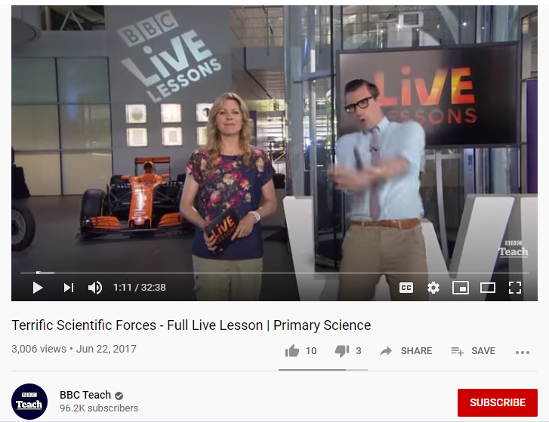
Rest of afternoon | Fresh air, Outdoor learning or Art or PE (see ideas sheets)
Evening | Reading for pleasure – to an adult/older sibling.

Daily timetable: Tuesday
9.15 – 9.45 | Morning activity: Reading, spellings, Rockstars Timetables (or you might want to do your Joe Wicks/other PE activity
9.45 – 10.30 | English: chapter 4 continued – complete exercise on slide 17 (language check)
10.30 – 10.50 | Break
10.50 – 11.50am | Maths  Year 6: Summer Week 3 – lesson 2 (compare and order fractions)  Optional Problem of the Day / investigation
11.50 – 12.50pm | Lunch
1pm – 2pm | Science – Forces  Begin work on putting together your powerpoint presentation on forces. I have included questions on the powerpoint slides, but it is up to you to change the font, size, import images and to answer these questions.  Yesterday’s video should have provided you with a good number of ideas. This link will also give you different clips and short texts to read about that you can include. It is important that you only copy and paste information that you properly understand. Try to put some of it into your own words where possible.  https://www.bbc.co.uk/bitesize/topics/znmmn39
2pm onwards | Fresh air, Outdoor learning or Art or PE (see ideas sheets)
Evening | Reading – to an adult/older sibling, discuss the text and make a prediction….who is your favourite character?

Daily timetable: Wednesday
9.15 – 9.45 | Morning activity: Reading, spellings, Rockstars Timetables (or you might want to do your Joe Wicks/other PE activity
1 hour | English:  Listen to Chapter 5 on https://www.bbc.co.uk/teach/school-radio/english-ks2-friend-or-foe-episode-5-one-good-turn-deserves-another/z73qkmn. I haven’t included the whole text for this chapter so I would like the children to really concentrate on just listening to the audio.  Then read the short extract (slides 20-21) and then complete the table on slide 22 (balanced argument 1 – note taking)
10.30 – 10.50 | Break
10.50 – 11.50am | Maths  Year 6: Summer week 3 – lesson 3 (adding and subtracting fractions)  Optional Problem of the Day / investigation
11.50 – 12.50pm | Lunch
1pm – 2pm | Science – continue Tuesday’s work
2pm onwards | Fresh air, Outdoor learning or Art or PE (see ideas sheets)
Evening | Reading – to an adult/older sibling, discuss the text and make a prediction….who is your favourite character?

Daily timetable: Thursday
9.15 – 9.45 | Morning activity: Reading, spellings, Rockstars Timetables (or you might want to do your Joe Wicks/other PE activity
9.45 – 10.30 | English:  Short formal written task – see slides 23-24 for help.
10.30 – 10.50 | Break
10.50 – 11.50am | Maths  Year 6: Summer week 3 – lesson 4 (mixed addition and subtraction)  Optional Problem of the Day / investigation
11.50 – 12.50pm | Lunch
1pm – 2pm | Science – continue Tuesday’s work
2pm onwards | Fresh air, Outdoor learning or Art or PE (see ideas sheets)
Evening | Reading – to an adult/older sibling, discuss the text and make a prediction….who is your favourite character?

Daily timetable: Friday
No new work set for today – please use this time to catch up on tasks that may have not been completed earlier on this week or from earlier weeks. If you are all up-to-date with your work, you can check out the daily lessons on BBC Bitesize to see if there is anything of interest. Or just enjoy some non-working time!

